

**Money and Credit, Twelve Months On**

Speech given by

Paul Tucker, Executive Directors, Markets and Member of the Monetary Policy Committee

At the Money, Macro and Finance Research Group 40th Annual Conference, Birkbeck College

12 September 2008

1

All speeches are available online at [www.bankofengland.co.uk/publications/Pages/speeches/default.aspx](http://www.bankofengland.co.uk/publications/Pages/speeches/default.aspx)

# MONEY AND CREDIT, TWELVE MONTHS ON

As many people have said, this is a challenging time for policymakers. But the real challenge is for households and firms in the real world who are having to navigate the fallout from the extraordinary combination of financial and commodity shocks rippling through the world economy. Our job as policymakers is to make that process as smooth as it can be over the medium term. And having our eye on the medium term means we must ensure that the gains of the past ten-to-fifteen years in stabilising inflation are not frittered away.

In confronting that task, policymakers are having both to make big picture judgments about the balance of forces buffeting the UK economy; and to apply areas of economic theory that stretch the frontiers of existing research. So, in joining your research conference this morning, I want to sketch, broadly, what the current conjuncture suggests, from the policymaker’s perspective, should feature in the future research agenda of monetary economists.

# The current conjuncture, and policy

By way of establishing the context, I will begin with the Bank of England’s most recent economic forecast. In August, the Monetary Policy Committee published our latest projections for output growth and inflation. On the then profile of market interest rates, the Committee as a whole1 judged that, most likely, output growth would slow quite sharply during the current year and would be anaemic for a period thereafter. Crucially, the balance of risks to that most likely (or modal) outlook was judged to be on the downside. In other words, the *mean* forecast for output was somewhat weaker still. For inflation, meanwhile, the most likely outlook was that, after an uncomfortably high and protracted spike, it would fall back to a little below the 2% target by the end of two years, and would continue to drift down thereafter. In other words, the crucial judgment was that the accumulation and persistence of slack in the economy would most likely be enough to avoid inflation getting out of control.

That was the part of the August projections that captured the attention of the markets and commentators.

*But*, collectively, we also concluded that the balance of risks to the inflation outlook was to the upside, so that the *mean* for inflation was actually above the 2% target at around two years or so.

That’s not without significance given that most analytical models suggest that policymakers should set policy in the light of the mean, not the mode – although a better description of the MPC’s approach would be to say that we take account of the nature of the entire distribution of risks.2

Now, putting this together, the following inference can be drawn; and I hope that I shall be excused if I plod through this in slow motion. Focusing on a roughly two-year horizon, if inflation was most likely to be below target in the context of the August modal forecast for output, then it would be even further below target if the MPC’s view in August of the downside risks to growth were to materialise (ie consistent with the mean path for output but no further adverse shock to costs). But, in fact, the mean path for inflation was *above* target at around two years. That underlines the hefty upside risk to inflation that featured in the Committee’s August projections.

Indeed, we cannot be remotely complacent about the risks in either direction. This is a delicate balance, and one that is developing from month to month. It is a convenient but in some ways misleading shorthand to characterise the Committee as currently balancing a growth risk against an inflation risk. Given our mandate – and, indeed, given how the economy works – that is better thought of as our having to balance the downside risks to inflation over the medium-term against the upside risks to inflation over the medium-term. So, perhaps contrary to some recent commentary, the MPC remains as focused on medium-term inflation as ever. No shift in the underlying reaction function. No shift in the aversion to inflation (or to deflation). But, of course, the current environment is highly unusual and our reaction function cannot be written down as a fully specified state-contingent rule; and so everyone is discovering that we truly are committed to low inflation in the medium term.

The mandate is expressed in terms of stable low inflation because that is what central banks can deliver over the medium term, and because nominal stability is a precondition for sustainable growth.

There is not a comfortable medium-term trade off between growth and inflation. Inflation is just the opposite of a free lunch. If in the interests of sustaining growth in the short run, we were to risk letting inflation become established at higher levels, things could easily get out of control as higher medium-term inflation expectations would become embedded. We would then find it much harder to bring inflation back to target, and could well end up having to generate a serious recession to put the genie back in the bottle. The experience of the thirty years before the current

regime demonstrated the economic and social costs – to households, livelihoods and businesses – of what that entails. The MPC’s inflation targeting mandate is the expression of those lessons that

– tragically for millions of people, given the chances of getting stuck in unemployment – UK policymakers had to learn. We’re not about to give up on the mandate. Success in anchoring inflation expectations in line with the target will give us more scope over time to cushion the economy from the adverse shocks to growth – which of course we would want to do when we can, consistent with medium-term stability.

What does, of course, shift as the months pass is our assessment, as nine individuals, of the balance of risks to inflation, given changes in the economic environment. And quite a lot has happened since our August forecast.

In the six weeks or so since the Committee’s August report was finalised, the signs of weakening in the UK’s major trading partner, the euro area, have intensified. Growth appears to be slowing in parts of Asia too. And in the US, the housing market has not yet obviously stabilised, which is probably a precondition for broader recovery there. Domestically, the output data have been on the soft side, moving into line with the battery of surveys and the Bank’s regional Agents. The labour market also appears to have softened, with unemployment rising and fewer vacancies advertised. It is perhaps not surprising that, compared with recent slowdowns, there should be less hoarding of labour if firms expect the adverse environment to persist for a while; and with tighter credit conditions, stretching working capital, making it harder for firms to finance the retention of a less-than-fully-occupied labour force. In the manufacturing sector, input and output price inflation have edged down very slightly. In the service sector, the data are less timely, though surveys have started to indicate some slowing in the pace of inflation. Commodity prices – not only energy, but food too – have continued to fall, perhaps reflecting the effects on global demand of the earlier price rises and the reduction of subsidies by a raft of emerging-market countries.

Equities have fallen around 3%. But sterling’s exchange rate has fallen – by around 4% since the MPC’s August meeting; and by about 15% since the beginning of 2007, so that, in sterling terms, the fall in oil prices has been less pronounced over the past month or so.

On balance, those developments mostly comprise downside news, since the August Inflation Report, to the outlook for demand and for inflation. But the recent depreciation of the exchange rate has to be offset against that. And headline inflation has reached 4.4%. It will probably rise

further. The Committee can and will ensure that this is a temporary state of affairs. But, for the moment, inflation expectations do continue to flash an amber light.

Meanwhile, credit has remained tight, and underlying money growth has decelerated, implying that monetary conditions may be leaning against those incipient inflationary pressures.

At the end of the last year – some months’ after the onset of the market turmoil – I set out some of the thinking that guided my interpretation of the monetary data and how it related to my policy decisions3. I stressed that “we must try to avoid a vicious circle in which tighter liquidity conditions, lower asset values, impaired capital resources, reduced credit supply, and slower aggregate demand feed back on each other”. A vicious circle between the world financial system and global economy has so far probably been kept at bay; global growth has slowed not collapsed. But there is no denying an adverse feedback loop between tightening credit conditions, the macro slowdown, and the perception that that will in time impair banks’ asset portfolios. So it seems timely to revisit some of the issues of ‘money and credit’.

# The Taylor-rule framework for thinking about policy

It is well over a decade since John Taylor set out what has become part of the current orthodoxy of monetary economics. His rule looks something like this:

*it = Πt +r*t+ a(Πt – Π*t ) +b(yt-y*t )*

This is, at its roots, a Wicksellian view of the world.4 By fixing the short-run nominal rate, the central bank can, given stickiness in prices over the short run, shift the short *real* interest rate – both in absolute terms and, more particularly, relative to the short-run real rate that would equilibriate demand and supply.5 So that gap between the short real rate and its ‘equilibrium’ can be thought of as representing the stance of monetary policy, which should be chosen by the central bank in the light of the extent to which inflation deviates from target, and to which aggregate demand deviates from the supply capacity of the economy. Implicit in this rule is that the textbook policymaker knows how the degree of slack in the real economy acts on future inflation (or the slope of the Phillips curve).

The two forces sweeping through the world economy test the way policymakers typically apply various elements of this set up in more routine circumstances.

For example, how do the commodity price rises and, separately, the credit crunch affect the ‘equilibrium’ short-term real rate? Is the actual short real rate still an adequate proxy measure of monetary conditions? Is the ‘normal’ relationship between economic slack and future inflation intact?

# The cost shocks, and monetary conditions

Although they have fallen by nearly $50 since the peak reached in July, oil prices are still up more than 200% since the middle of 2003; and, indeed, around 3% since the beginning of this year. As oil is a key input to production, this acts like a negative supply shock for the Western economies: it costs firms more to produce the same level of output than before the run up in oil prices. And, like a tax, it acts to redistribute spending power from energy consumers to energy producers. In those circumstances, real-take home pay has to grow more slowly for a while in order to avoid the capital stock shrinking as firms sought to maintain the internationally-determined required rate of return. The role of monetary policy is to facilitate that process, recognising the potential redundancy of some capital resources given higher energy prices, and the upward pressure on real interest rates as households seek to borrow to tide them over the tough times.

In other words, in the now standard set up, taking the cost shock on its own, the equilibrating short-term real rate (r star) has risen and the economy’s potential supply (y star) has probably fallen. So, ignoring other developments, policy would have to be tighter than otherwise, even if the direct effects of the cost rise on the price level were accommodated. But, of course, other things have been going on, and it is the *net* effect for our policy rate that matters. And that involves making a judgment about the tightness of credit conditions.

# The credit shock and monetary conditions

In conducting policy, commentators usually take the short-run nominal interest rate, Bank Rate, as a summary measure of monetary conditions. If Bank Rate is increased, monetary conditions are being tightened; and conditions are being loosened if Bank Rate is cut. There are a few important

simplifying assumptions being made here – assumptions whose validity in current circumstances is doubtful.

In the first place, that view of the world implicitly assumes that the equilibrium real rate is stable over time, whereas in fact it will move about.6 Sometimes the central bank will need to change its policy rate simply in order to maintain unchanged monetary conditions (as proxied in the literature by r minus r star). In the same vein, if near-term inflation expectations rise or fall, our nominal policy rate may need to change just to leave the actual short real rate unchanged. In other words, we can fix only one thing – the short nominal rate – but what any particular level of Bank Rate means for monetary conditions will depend on short-run inflation expectations and on the equilibrium real rate needed to balance the economy. Both will likely have changed materially in the face of the cost and credit shocks.

What our Bank Rate will mean for monetary conditions will depend on how it relates to the panoply of other interest rates on financial contracts. In fully efficient markets, the risk-free rate is a fully satisfactory summary statistic; other rates fall into line through arbitrage, with differences reflecting risk premia. More practically, it can typically be assumed that the rates charged on private sector loans are maintained at fairly stable spreads relative to the risk-free yield curve (ie given the expected path of the policy rate). And, related to that, it can also typically be assumed that the degree of credit rationing in the economy is broadly constant over time. Obviously, neither of those things is true at present.

The most unusual, and stretched, circumstances lie within the global financial system itself. The premium on unsecured interbank lending has risen (Chart 1); and growth of such lending has slowed. This reflects a desire to hoard liquidity in a hazardous environment; and heightened aversion to taking on unsecured credit exposures for term maturities. Banks are, in consequence, deleveraging7 their balance sheets. Broadly, they can do so in two ways – raise extra capital, or shrink (the pace of growth in) their balance sheets. Both have been underway. The balance sheet shrinkage is reducing the supply of credit to households and firms. But there is differentiation across the banking industry, according to size and strength.

In that environment, spreads on corporate bonds are higher. Many corporate and household lending rates have been affected by the rise in Libor relative to risk-free rates. And retail rates – for both loans, and some deposits – have risen relative to the relevant risk-free rate. Effective rates on

some types of lending are not much changed since last summer, but we have cut Bank Rate by 75bp and the risk-free curve has shifted down (Chart 2).

All this is true in the US too, probably more so. That has led John Taylor himself to suggest8 that, to maintain an unchanged policy stance, the policy rate should be reduced by the extent of the widening in spreads. In fact, as I am sure Taylor recognises, it is nowhere near so straightforward

* if for no other reason than that, for the real economy, the most severe feature of the credit shock is the rising incidence of quantity rationing.9

There appears to be some discrimination between lower-risk and higher-risk borrowers in the household sector. Rates on fixed-rate mortgages have recently been cut for lower loan-to-value borrowers. We have added a question to our current Credit Condition Survey, due out later this month, to gauge conditions in that part of the market. Plainly, conditions have tightened a lot for riskier borrowers – households and firms. That means we need to look at quantity data as well as at the price of credit. For companies, money growth has fallen very sharply. Lending held up for a while, but possibly in part because firms were drawing on committed lines of credit while they were still available on pre-turmoil terms. The Credit Conditions Survey has signalled a clear tightening (Chart 3).

To translate this back into a Taylor-rule world, we would need to know the so-called ‘shadow prices’. Of course we don’t know those unobservable prices. But we can, perhaps, get a broadbrush handle on the materiality of the tightening by using estimated equations for credit (and money) demand, holding all other influences constant.10 There is just huge uncertainty about such estimates but, for what it’s worth, they indicate a material tightening from this source.

Alternatively, that can be thought of as being equivalent to a fall in the real risk-free rate of interest that would equilibriate supply and demand11. Taken on its own, this rather leans against the proposition, advanced by a number of commentators, that monetary conditions are *loose* on the grounds that deducting CPI inflation of between 4 and 5% from a Bank Rate of 5% leaves a ‘real rate’ close to zero. First, as I have been arguing, it is vital to take into account the possibility that the real rate warranted in the current conjuncture has fallen.

Second, headline CPI might not be the best deflator for calculating the relevant real rate of interest. CPI may not necessarily be the price – the ‘own real rate’ – relevant for individual households’ and

businesses’ spending decisions.12 For example, firms’ investment might be more dependent on the price of capital goods. Despite the pickup in oil prices, the pace of inflation for capital goods has been much lower than for CPI. So that might suggest a correspondingly higher real rate for businesses than one based on CPI (Chart 4). A similar question could be posed about the real rate facing households, given that the CPI currently excludes the costs of owner occupation.

So one can safely conclude that it is not all straightforward at present to calibrate monetary conditions.

For researchers, that underlines the importance of renewing work directed at gauging monetary conditions. A recent paper by Michael Woodford13 concluded that information from money and credit quantities could not add anything to spreads; and, what is more, that they were not as useful as spreads because the quantity effects of a tightening become apparent only with lags. The set up in Woodford’s paper does not, however, involve quantity rationing. When such rationing occurs, data on the quantity of lending and money may be more useful, even with a lag, than the shadow prices that cannot be observed! Of course, I absolutely do not want a reversion to oversimplified Monetary Conditions Indices, which set a trap for policymakers by ignoring the nature of the shocks that shift credit supply and other financial variables. But we do need to have a better quantitive understanding of how the equilibrium real rate (r star) shifts with shocks to the financial parts of the economy.

For UK policymakers, overall, the sharp slowing in corporate and household credit and money growth signals that monetary conditions are quite tight. Tighter bank lending conditions will make it harder for households to maintain their spending during this testing period – when the rise in energy and food prices has squeezed disposable incomes; and when the savings rate was already low. Similarly, with less easy access to credit, it will be harder for firms to bridge to the expected recovery without cutting costs. On the whole, the corporate sector probably entered this episode with stronger balance sheets, leveraged buy-outs aside, than the household sector. But, as the months have passed, firms have been registering a greater sensitivity to tighter financial conditions.

The lags between the incidence of the financial shock last summer and its impact on spending in the economy have been fairly drawn out. It is striking that through the autumn and perhaps even into the spring, a number of commentators thought this was essentially a problem for Wall Street

not Main Street. We need more research to help understand those lags, and whether the credit shock has been more potent for its coinciding with the climb in commodity prices.

That assessment has informed my view that slack will accumulate, leaning against – but not eliminating – the current upside risks to inflation. Indeed, the best gauge of our view of monetary and credit conditions is to be found in our periodic forecasts for growth and inflation.

# Nominal trends

A hazard, given the current paradigm in monetary economics, is that its all too easy for policymakers to fall into the habit of never mentioning anything nominal – apart from inflation expectations.

One of the key challenges for monetary researchers is, accordingly, to discover more about what determines inflation expectations. Meanwhile, whatever is incorporated into forecasting models, policymakers cannot sensibly just take it for granted that expectations are anchored, so that inflation will painlessly come back into line with the target whenever it is driven away by temporary cost shocks. What that means right now is that arresting the upside risk to inflation cannot rely entirely on real-economy interactions.

So what diagnostics have we got on nominal trends, right now?

On the whole, they are not signalling an imminent resurgence in inflationary psychology. Nominal demand growth has slowed quite sharply (Chart 5). Adjusting for various misleading technicals,14 broad money has decelerated sharply (Chart 6). The rate of growth of so-called Divisia money, a measure of transactions balances, has similarly fallen sharply. And in the labour market, nominal earnings growth has recently been below 3.5%, although the annual wage round lies ahead.

Sterling’s exchange rate has fallen, however. That might be consistent with the foreign exchange markets expecting a nominal shock in the future. But there are other possible explanations, notably that a risk premium may have become incorporated to compensate for uncertainty in the outlook.

Had there been a shift in the market’s inflation expectations, the obvious place for that to show up would be in the yields on nominal government bonds. For medium-term maturities, so-called

‘breakeven inflation rates’ – derived from the difference between the yields on conventional and inflation-indexed gilts – have stabilised over the past few months. Given the frictions that many believe distort indexed-linked yields,15 I also like to look directly at nominal forward rates. The underlying thought is that, relative to fluctuations in bond yields brought about by past shifts in inflation regimes, longer-term risk-free real rates may not move around a great deal, so that any systematic inflationary impulse would be quite likely to show up in nominal yields. Consistent with that, following the UK’s disinflation in the early-1990s, medium-term nominal forward rates fell by around 400bp. Since the new monetary regime became established in the late 1990s, they have been more or less stable, and currently remain within the range prevailing over the past decade or so.

Surveys of household inflation expectations tell a broadly consistent story. For near-term horizons, they have picked up sharply. What limited information we have on the public’s medium-term expectations suggests that the expectations might have been more contained, and might more recently have started to edge down a bit. But it is hard to know how much weight to place on that.

But if the upside risks to medium-term inflation are not yet firmly embedded in expectations and so are not evident across the nominal indicators, we certainly cannot conclude that the risk has passed.

Headline inflation outturns remain elevated, and could top 5% – well above the 2% target – for a number of months. Not only have goods prices accelerated, reflecting the direct impact of food and energy prices, but services inflation has risen too (Chart 7). As a diagnostic of the underlying upside risks, ignoring the direct effect of past increases in food and energy prices, inflation has reached around 2%. Sterling’s recent depreciation will give a further impulse to import prices; and so, other things being equal, may stretch out the period of uncomfortably high inflation, endangering inflation expectations.

Moreover, there remains a risk of continuing inflation impulses from the persistence of imbalances in the global economy.

# Global inflation, global imbalances and the international monetary regime

The rate of nominal expansion in much of the emerging market world has remained brisk. From our point of view, up until recently that seemed to add to the upward impetus to commodity prices, exacerbating the upward pressure on our firms’ costs.

Of course, part of the rise in commodity prices over the past few years is explained by a profound structural shift as the world economy is joined by large, rapidly developing economies which are increasingly energy intensive. In addition, nominal demand has probably played a role recently. Some EMEs have exchange rates that are fixed, more or less, to the US dollar, and so have been importing a monetary easing, which they hardly needed, as the FOMC cut the Fed funds rate to address domestic US circumstances. In other countries, there has also been less than complete sterilisation of the monetary effects of exchange rate intervention. Absent offsetting policy action, eventually the nominal expansion permitted will be dissipated in rising inflation and so an appreciation in *real* exchange rates. For a given path of nominal demand, that would tend to reduce the pressure of demand on global commodity prices, as many of the largest EME economies are, basically, commodity importers themselves. But persistent elevated inflation in the EMEs would also increase the nominal price of some of our imports, unless an adjustment in nominal exchange rates were permitted. In fact, over recent months there have been some steps towards taking domestic monetary action across a number of emerging market economies. But there is a risk that higher EME inflation will persist if, left unchecked, it becomes embedded in inflation expectations.

With inflation also elevated across the major industrialised economies, this underlines the risk to global inflation from imbalances in global supply and demand. Individual countries can suffer exogenous shocks to inflation from commodity prices, but that is essentially a relative price shift, to which the world economy has to adjust. By contrast, a persistent rise in inflationary pressures cannot be exogenous for all countries collectively. In that respect, the international monetary regime, and the global imbalances it has sustained, continues to pose risks to the outlook for our economy.

Indeed, in terms of where we find ourselves, we must take care not to put the cost shock and the credit shock in completely separate boxes. They both owe something to global imbalances. Early

commentators on the developing international monetary system, combining a mixture of floating and fixed-rate exchange rates (so-called Bretton Woods II),16 were inclined to the view that current account imbalances would prove sustainable – essentially because Asia would, they assumed, continue to finance the USA’s savings deficit. But, as has become apparent over time, that seemed to rely on the invisible hand smoothing over the counterpart imbalances within some net debtor economies, notably the USA; or, more crudely, of it making no difference that, in aggregate, American households had effectively given up saving.

Given the now widely acknowledged *ex ante* imbalance a few years ago between global investment and Asian-fuelled global saving, this was associated with a compression of long-term risk-free rates and an associated rise in asset prices. And given frictions elsewhere in the system, including the US GSE’s guarantees reducing the headline returns on prime-mortgage securitisations, that contributed to compression in risk premia. And that, I fear, fuelled a ‘search for yield’ in which investors, having enjoyed the extraordinary windfall gains that accompany rising asset prices, extrapolated forward their elevated *ex post* returns into *ex ante* requirements (Diagram A).17 (Such extrapolation amounts to a bubble, but via the channel of a requirement or target rather than, directly, a simple expectation.) There’s only one way to deliver on such requirements in those conditions: take more risk and hope no one prices for it. Leverage and maturity transformation were the order of the day. Macro met finance, and the results were unhappy – a theme I shall return to later.

For too long without success, monetary policymakers and international institutions called for resolution of the global imbalances. Perhaps with hindsight, the industrialised economies should have been clearer about their own course in a second-best world in which some important exchange rates have remained semi-fixed for longer than believed ideal. The second-best probably involved measures to generate more domestic saving; may have invited tolerance for temporarily lower inflation; and perhaps tighter regulation of liquidity provision by the commercial banking system. But whatever the hindsight, there remains a pressing need to evaluate now the continuing risks from the pattern of global current account positions and capital flows.

For researchers, this unfinished episode in global economic history underlines the significance of international monetary economics, but perhaps also a need to integrate it not only with the theory of asset pricing but also with a rich appreciation of credit creation and risk.

# Risk premia, money, default and crises

Indeed, an implicit theme running through various threads in my remarks this morning, which I shall now try to pull together, is the need for further progress in integrating macroeconomics and finance – applied as well as theory. I will give a few reasons why.

As well as compensating for expected default, expected inflation and so on, yields on assets embody risk premia to compensate for uncertainty in future returns. In the modern literature, these risk premia are taken to be determined by how useful a financial asset is in helping households to smooth the path of their consumption. Assets that deliver low returns during bad times don’t contribute much to helping households sustain consumption, and so carry a higher risk premium.

So risk premia might vary with the volatility of the asset return; the volatility of consumption; and with the correlation between asset returns and consumption. Like other economic variables, such premia may change as their underlying determinants change, and given the nature of the ‘shocks’ affecting the macroeconomy. All that is familiar, fairly orthodox stuff these days. Indeed, an extraordinary amount of work at the macro/financial frontier has been going on over recent years. But as John Cochrane has commented, “work has barely begun”. 18 From a policymakers’ perspective, that does seem to be the case.

First, while papers are still produced in the tradition that “macroeconomists can safely go on ignoring finance”, we – policymakers – are having to make sense of a macro environment in which the supply of credit has been interrupted by problems sourced in part to swings in risk premia, and quite possibly swings in risk aversion. Models incorporating risk premia – and, indeed, embracing bubbles – might just help us with that.

But it is striking that, so far, the progress in finance hardly features in the macro models used around the world for forecasting. Indeed, such models barely recognise the existence of financial instruments beyond risk-free bonds and equities.19 In modern DSGE models, asset prices (and so risk premia) merely reflect economic developments; they are not ‘actors’ in any way. Even if we were to accept that risk premia are not ‘actors’, for policymakers they might serve as useful diagnostics of what is going on in the economy – of the nature of the underlying shocks – given that asset price changes are typically apparent some time before the associated real economy adjustments. On that view, we need research that will help us read the ‘risk premia’ tea leaves.

For example, an increase in premia that could be traced to an increase in the correlation between consumption and investment returns, might point to a prospective increase in households’ precautionary saving. But it’s less obvious, at least to me, what macroeconomic developments I should expect if risk premia rose due to an ‘exogenous’ rise, say due to reduced market making, in the volatility of asset prices. We also need to be able to make sense of shifts in relative risk premia on different asset classes. We need models that can say something useful about the compression, and then widening, in credit and liquidity risk premia that in some ways define the current financial turmoil. We need to know whether or not those shifts reflect changes in fundamentals, or unwarranted ‘exuberance’ or ‘fear’ in the markets; and whether or not they have implications for demand and supply conditions in the real economy.

Second, very little has been said about how, or whether, the supply of money (or monetary policy) may affect risk premia. Years ago Brunner and Meltzer set out a view20 of how shocks to the supply of base money were transmitted to the economy through effects on asset prices over and above the impact on the risk-free discount rate, but through liquidity (and maybe other risk) premia. More recently, some policymakers,21 have conjectured that swings in the supply of broad money (via bank lending) can be associated with shifts in risk premia too. The thought is that in a world in which different assets are not perfect substitutes for each other, whether money is over or under-supplied can affect the relative value of other financial assets. If the channel is thought to work through broad money, as transactions balances,22 then of course it is the supply of bank lending that matters. Essentially, when ‘liquidity’ is plentiful, it may be undervalued. That may build a bridge to the literature on how the supply of credit from the banking sector can influence the liquidity of asset markets.23 This echoes my earlier discussion of the potential utility, as indicators, of the data on money and credit quantities when the degree of credit rationing shifts.

We’d do better at making sense of those issues if we had a better understanding of the determinants and macro-significance of risk premia in the first place.

Extending that point, the literature may too easily dismiss the possible effects on prices of the demand and supply of financial assets more generally. But we need testable theories as to why, and the circumstances in which, they might matter.

Finally, looking beyond the ex ante compensation for risk, we also need to have better models for exploring what can happen – in the financial system and in the macroeconomy – when nasty forms of risk do actually crystallise. Default comes to mind.24 Bank default is a special case, given the

special role of banks in a monetary economy. And, guess what? Banks don’t really feature in modern macro models. Of course, incorporating those features of the real world is incredibly hard, involving heterogeneous agents, incomplete contracts and markets, and uncertainty.

Uncertainty needs to be underlined. It isn’t clear whether existing models could explain the swings we have been experiencing in *some* asset prices. Is that something to do with market participants having become radically uncertain about the nature of the underlying distributions? And do asset prices become actors in those circumstances?

Over many decades now,25 elegant models have been developed for studying financial market distress in the abstract – whether affecting banks or asset markets. This, of course, involves strategic interaction amongst agents. We have other models in which the probability of such distress may be related to various characteristics of banks, such as whether they are comfortably within thresholds for capital adequacy – the argument being that as they get closer to the threshold, depositors become less confident about the stability of each other’s behaviour. 26 And we have models in which bank capital is affected by macroeconomic developments; and models in which, through financial accelerator-like mechanisms, impaired bank capital affects the supply of credit,27 and so potentially macroeconomic variables. But we don’t yet have models in which the determinants of the probability of banking system distress are influenced by the macro environment; and in which such distress can, really, occur and affect the macro environment. That seems to call for somehow embedding game-theoretic strategic interactions within dynamic macro models.28

Overall, truly incorporating risk into our thinking has to be one of the last great frontiers for applied macroeconomics. For central banks, that would help to meet the challenge of integrating our monetary policy and financial stability missions, which cannot be separated in a monetary economy.

# Summary and conclusions

This morning I have offered some thoughts on what one policymaker would find useful from future research in applied monetary economics:

* the determination of fluctuations in inflation expectations
* a revival of interest in money and credit quantities, especially when credit rationing means that we cannot observe ‘shadow prices’ and so cannot live entirely in the modern textbook world of prices
* and if, as I believe we should, we are going to continue to think largely in terms of prices, then we need more work on the determination of risk premia on a range of financial assets, and the information they can give us on the real economy, integrating this into our workhorse macro forecasting models
* empirical work on the lags with which shocks to the financial system feed through to the real economy, and on the conditions for the impact to matter
* work designed to help *quantify* how different shocks to supply and demand affect the equilibrium short-term real interest rate
* greater interest in the international monetary regime, and on how countries may be able to shield themselves during a period of unsustainable imbalances without succumbing to ‘begar thy neighbour’ policies; and
* the development of dynamic macro models in which really bad things, such as defaults, bank distress and asset price collapses, can happen and can have macroeconomic effects.

That is quite a shopping list. The official sector, internationally, could, in my view, probably help

* both researchers and itself – by producing data on financial flows and stocks as rich as the real economy data we collect. I have in mind things like the Federal Reserve’s ‘Flow of Funds’ statistics. As well as being of immediate practical use, over time there would be benefits from the richer empirical research it would allow your community to conduct. The underlying thought is that, until we know more about risk premia, we should not give up tracking quantities. Doing so in the future might aid comprehension of the risks in the financial system.

The challenge for policymakers is no smaller than that for researchers. We must tackle the task at hand with the tools we have. There are substantial risks to inflation in both directions over the medium term. But at present, the most likely prospect remains that, as the global economy slows, accumulating slack in the economy will head off the upside risks to inflation. That strategy relies not only on real-economy interactions, but crucially on the credibility of the target and the Committee. Above all else, therefore, we must be clear about our mandate: to deliver stable inflation, at 2%, over the medium term.

# Chart 1: Premium on unsecured interbank lending (Libor-OIS)



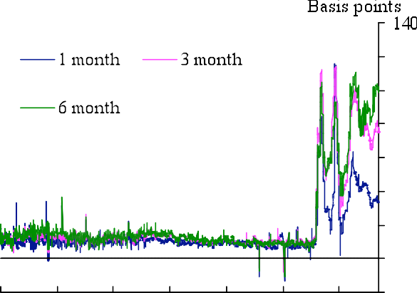

**Chart 3: Credit condition survey(a)- large corporates**

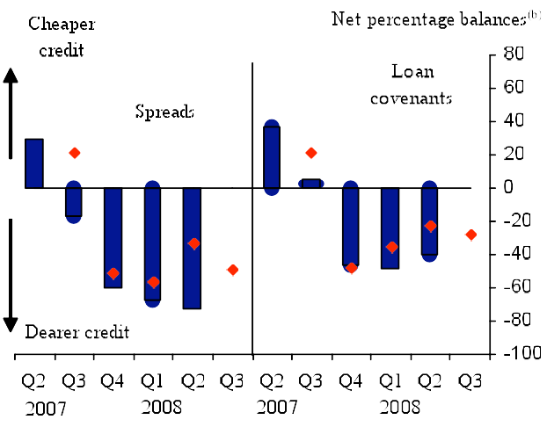

1. The blue bars show responses over the past three months. The red diamonds show expectations over the next three months. Expectations balances have been moved forward one quarter so that they can be compared with the actual outturns in the following quarter.
2. A positive balance indicates that spreads have become narrower, such that it is cheaper to borrow, or that the terms and conditions on which credit is provided have become looser.

# Chart 2: Selective effective rates and Bank rate

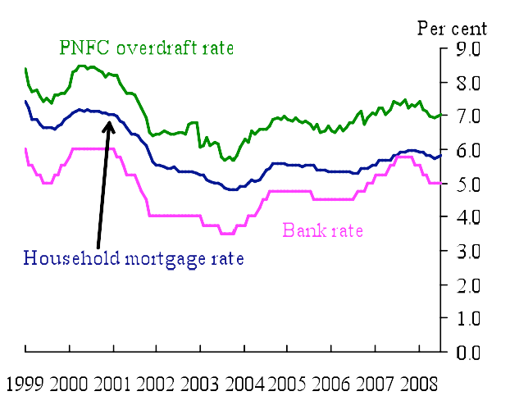

**Chart 4: CPI and the capital goods deflator**

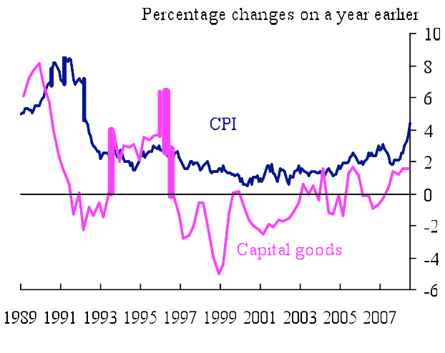

**Chart 5: Nominal demand Chart 6: Divisia money(a)**



**Chart 7: CPI inflation**

(a) Quarterly data prior to 2000, monthly data since then.

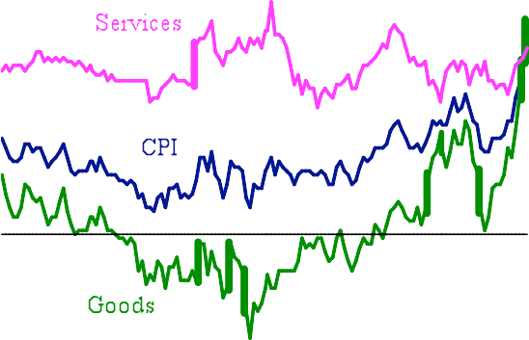

# Diagram A: Stylised effect on equity returns of a fall in risk premia

On -perio *e -pos* equity

Time

Tim T+ Premium falls by Y% each period

Pre shoc stead stat return

Pos shoc stead stat return

tim

ENDNOTES

1 See Tucker, PMWT, 2008 “Making monetary policy by Committee” Bank of England Quarterly Bulletin 2008 Q3 (forthcoming) for some thoughts on the relatively collective nature of the MPC’s forecasts given its one person, one vote decisions on Bank Rate.

2 I have to say that the textbook stress on the mean (or expected value) might be somewhat overdone in some

circumstances, in particular where the mean is materially influenced by certain types of low probability/high impact risks. I hope the following will illustrate that. Imagine, not in the current context, that there is a risk of a dollar collapse against the euro, the currency of the UK’s largest trading partner, but without a similar risk of sterling collapsing. Say the probability is judged to be low, but the impact large; so that, in the

probability-weighted way, it is enough to shift the mean outlook for future inflation. If (if) the risk crystallised, the export-oriented euro area would be adversely affected, and the UK with it. But, seriously, should the UK cut the policy rate to head off the risk of a dent to output from a dollar collapse that hadn’t yet occurred? I don’t think so.

3 See Tucker, PMWT (2008) “ Money and credit: banking and the macroeconomy”, Bank of England

Quarterly Bulletin, 2008 Q1 pp 96-106.

4 See Wicksell, K, 1898, “Interest rates and Prices”

5 Typically, policymakers think about that in terms of the ‘output gap’, reflecting firms’ capacity utilisation and slack/pressure in the labour market. By contrast, in the academic literature – notably Michael Woodford’s

*Interest and Prices* – the benchmark is to set monetary policy in order to offset the frictions in the economy, so as to obtain the conditions that would prevail if prices, wages etc were fully flexible. Policymakers and academics need to resolve how big the gap is between those two approaches.

6 See Neiss, K and Nelson, E (2001) “The real interest rate as an inflation indicator”, Bank of England Working

Paper No 130.

7 See Tucker, PMWT (2008), “The credit crisis: lessons from a protracted peacetime”, remarks given at the Chatham House conference on “The New Financial Frontiers”. These remarks are also forthcoming in the 2008 Q3 edition of the Bank of England Quarterly Bulletin.

8 See Taylor, JB., (2008) “Monetary Policy and the State of the Economy”, testimony before the Committee on Financial Services, US House of Representatives, February and Mculley, P and Touli, R (2008) “Chasing the Neutral Rate Down: Financial Conditions, Monetary Policy, and the Taylor Rule”, Global Central Bank Focus, PIMCO.

9 Another reason reflected in the Curdia and Woodford (2008) paper is the fact that borrowers and savers have

different propensities to consume. Consequently a change in spreads will affect the ‘average rate’ faced by borrowers and savers in a different way from a change in the policy rate.

10 Based, for example, on Brigden, A and Mizen, P (1999) “ Money, credit and investment in the UK corporate

sector”, Bank of England Working Paper number 100.

11 David Miles has recently made a broadly similar point in ‘The cost of bank debt: rethinking the neutral rate’.

12 I owe this point to Mervyn King.

13 See Curdia V, and Woodford and M (2008), “Credit Frictions and Optimal Monetary Policy”, a paper discussed at the BIS Annual Conference in June 2008.

14 Broad money (M4) can be adjusted using Bank estimates of banks' intragroup business with other financial corporations, as well as banks' repo activity with LCH.Clearnet's RepoClear service. Such estimates are based

on anecdotal information provided by a small sample of banks. Work is under way within the Bank to improve the basis of these estimates, see Burgess, S and Janssen, N (2007), 'Proposals to modify the measurement of broad money in the United Kingdom: a user consultation', *Bank of England Quarterly Bulletin*, vol. 47, no. 3, pages 402-14.

15 Of course, if true risk-free rates fall then, other things being equal, nominal forward rates would fall too, and

so would not, on their own, be a good indicator of inflation expectations. Given the bulge in Asian savings, there are reasons to think that long real rates might have fallen. But this is much less pronounced in US$ TIP yields than in UK indexed-gilt yields, and so I incline to the view that the gilt-market ‘breakeven’ rates are somewhat distorted.

16 See Dooley, M.P, Folkerts-Landau, D and Garber, P (2003), “An essay on the revised Bretton Woods

System”, NBER Working Paper 9971. ‘System’ is not quite the right word, because it is not the product of collective international thought and planning.

17 See Tucker, PMWT (2006) “Uncertainty, the implementation of monetary policy and the management of

risk”, Bank of England Quarterly Bulletin 2006 Q2 pp 202-211.

18 See Cochrane, J, “Financial Markets and the Real Economy.

19 See Tucker, PMWT “Reflections on Operating an Inflation Target”, Bank of England Quarterly Bulletin, 2006 Q2 pp 212-224.

20See Tucker, PMWT (2007) “A perspective on recent monetary and financial system developments” Bank of England Quarterly Bulletin 2007 Q2 pp 310-316.

21 Including the current G of the BofE and myself; see King, M (2002) “No money, no inflation – the role of money in the economy” Bank of England Quarterly Bulletin 2002 Q2 pp 162-177

22 See Thornton, D. L, (2008) “Monetary policy: Why monetary matters and interest rates don’t”, Federal Reserve Bank of St Louis Working paper 2008-011.

23 See Allen, F, and Gale, D, (2007) “Understanding Financial Crises”, Oxford University Press.

24 Commenting on a recent paper by Michael Woodford, Charles Goodhart (pointed out that the model

incorporated credit risk premia but not default. Everyone is hoping that Woodford picks up the challenge. (See Goodhard, C, comments on ‘Credit Frictions and Optimal Monetary Policy’ by Curdia and Woodford (2008). These were given at the 7th BIS Annual Conference.

25 See Diamond DW, Dybvig PH, (1983) “ Bank runs, deposit insurance, and liquidity” Journal of Political

Economy 91, pp401-19.

26 See Rochet, J-C and Vives, X (2004), ‘Coordination failures and the lender of last resort: was Bagehot right after all?’, Journal of the European Economic Association, Vol. 2(6), pages 1116-47

27 See Adrian, T and Shin, HS (2008) “Liquidity and leverage”, Federal Reserve Bank of New York Staff Reports No 328, and Bernanke, Ben S., Mark Gertler, and Simon Gilchrist (1999). "The Financial Accelerator in a Quantitative Business Cycle Framework," in *Handbook of Macroeconomics*, Volume 1C, Handbooks in Economics, vol. 15. Amsterdam: Elsevier, pp. 1341-93.

28 I stress dynamic macro models because we do already have Arrow-Debreu type general equilibrium models in which default can occur; eg Tsomocos DP, Jackson P,and Catarineu-Rabell, E (2003), “Procyclicality and the

new Basel Accord – bank’s choice of loan rating system”, Bank of England Working Paper 181, and Dubey, P, Geanakoplos, J and Shubik, M (2000) ‘Default in a general equilibrium model with incomplete markets’, Cowles Foundation DP 1247, Yale University. The difficulty with such models for a macro policymaker is that they tell the end of the story, when all relative prices have been determined, whereas we want to enrich our grasp of the narrative so that we can influence the end of the story.